DevOps Challenge

Detailed step-by-step instructions for the installation process along with proper evidence (Outputs, and screenshots).

Challenge 1: Launch one aws ec2 and install jenkins.
Steps:
- Started by going to AWS and launched one instance
- Connected to instance with gitbash using “ssh -I key.pem username@publicipv4”
- After connected, made sure that the jenkins is not already installed using “cat /etc/os-release” command
- Instance was running on Amazon Linux 2023 and it uses “dnf package installer”
- Jenkins is not configured on Amazon Linux 2023’s server and it has its own repository
- Downloaded jenkins using “wget” command
- “wget -O “path_where_file_needs_to_be_downloaded” “download link””
- Downloaded jenkins key again using “wget” command
- Then installed jenkins in the server using “dnf install jenkins” command
- Made sure jenkins is available using “systemctl status jenkins” command
Screenshots:
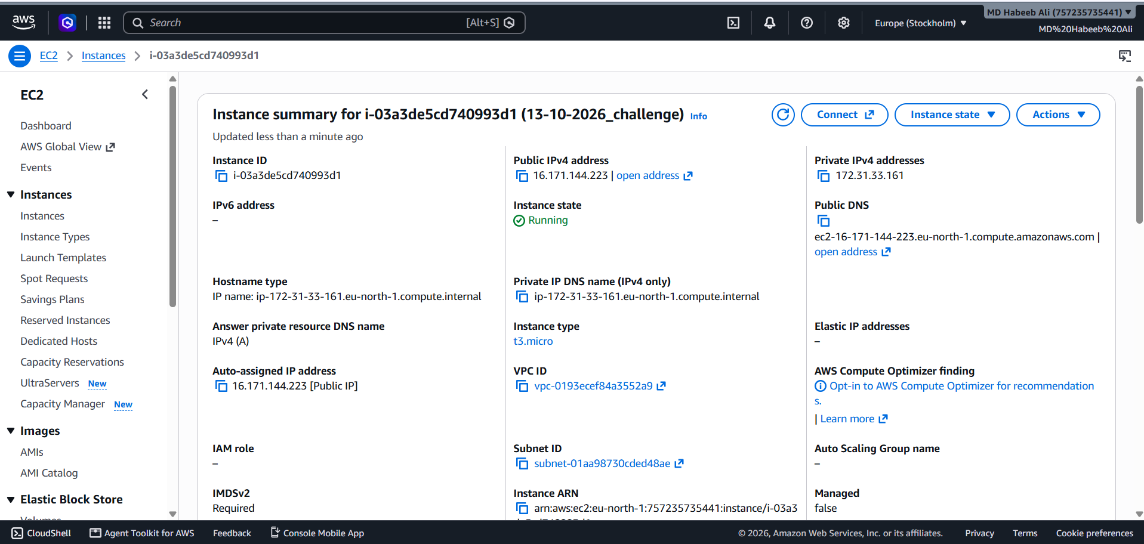
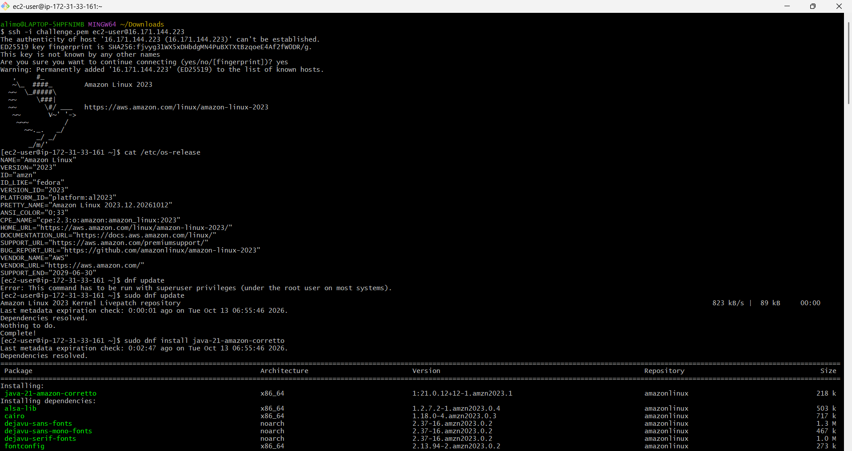
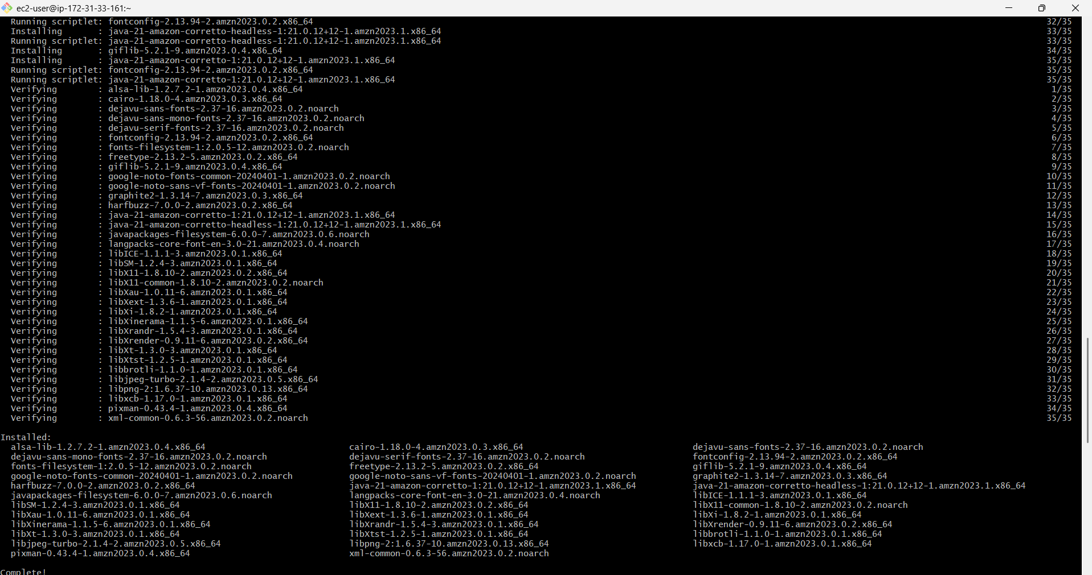
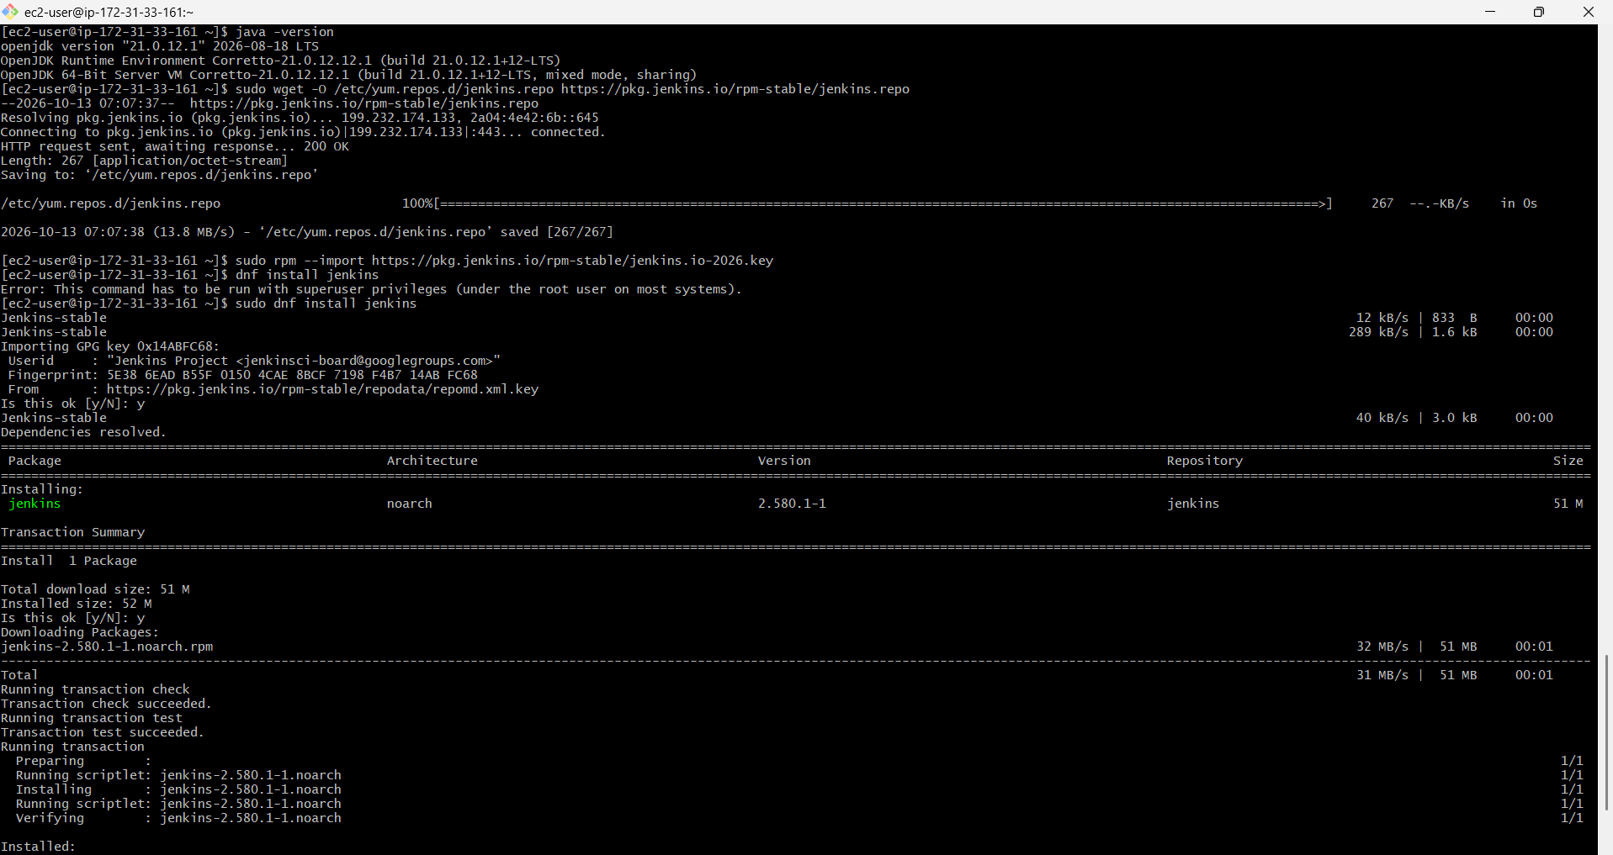
Challenge 2: Setup Apache Tomcat on Ubuntu Virtual Machine
Steps:
- As Apache Tomcat is designed to run Java web applications, so it needs a Java runtime.
- Made sure Java is already installed in the system by using “java -version” command
- Installed tomcat using “apt install tomcat9” command
- Enabled tomcat using “systemctl enable tomcat9” command
- Made sure it is enabled using “systemctl is-enabled tomcat9” command
- Made sure the setup is successful and the process is running using “systemctl status tomcat9” command
Screenshots:
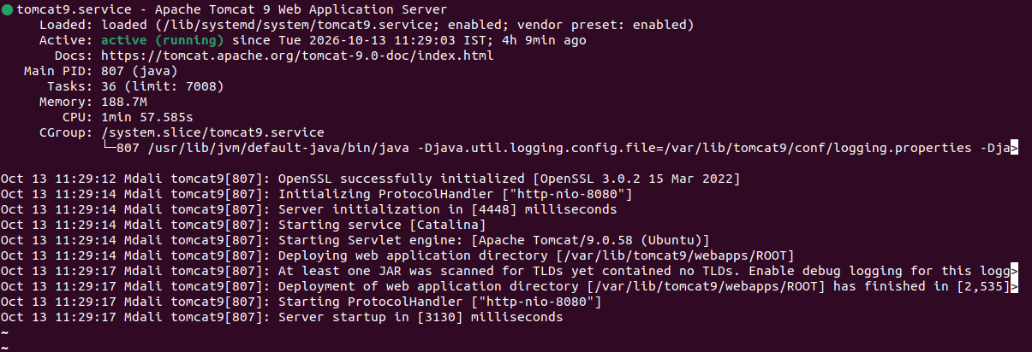
Challenge 3: Setup Docker Desktop on your local windows.
Steps:
- Verified Windows 11 version and enabled hardware virtualization
- Installed WSL 2 and Ubuntu using PowerShell
- Downloaded and installed Docker Desktop
- Verified Docker Engine functionality using “docker version” command
- Successfully ran the “hello-world” container
Screenshots:
